Patient Portal User Handbook

Table of Contents
Introduction 3
Navigation of Patient Portal 3
How to Use the Patient Portal 4
Patient Portal Home Page 4
Main Sections 4
Helpful Resources 5
Contact Technical Support 6
Preferences 6
Terms & Conditions 10
Health Record 11
Health Record Main Page 12
Create New Health Summary 14
Requesting a New Health Summary 14
New Health Summary 14
Download Health Summary 15
Download Health Summary Detail Page 15
Download Health Summary Zip File 17
Extracted Health Summary Files 18
Health Summary Read Me Text 18
Health Summary xml File 19
Send Health Summary 20
Health Summary Activity 20
Health Summary Activity Detail page 20
Print Health Summary 21
Print Health Summary Detail Page 22
Visit History 23
Visit History Main Page 23
Visit History Detail Pages 24
Results 25
Results Main Page 25
LAB Results Detail 26
LAB Results Comments 27
Microbiology Result Detail 27
Medications 28
Medications Main Page 29
Medication Detail Page 30
Allergies and Conditions 31
Allergy Detail Page 32
Conditions 33
Reports 34
Documents 34
Questionnaires 34
Questionnaires Main Page 35
Questionnaires Detail Page 35
Appointments 36
Billing 37
Billing Detail 37
Profile 38
Update Profile Wizard 39

Introduction
The Patient Portal offers secure electronic access as a service to patients who wish to view a summary of their medical record. This interactive web portal will empower patients and their families to take a more active role in their care by providing easy, secure access to their health information and online communication with Lincoln Surgical Hospital and Nebraska Surgery Center staff.
The Patient Portal gives patients instant access to their health information, including laboratory results, medications, allergies, demographic information, visit history, discharge/aftercare information, and more. Patients can also access their billing account balances. In addition to handling their own care, parents and health care proxies with authorized consent will appreciate the ability to access the records of those individuals for whom they manage care.
Lincoln Surgical Hospital and Nebraska Surgery Center encourages all of their patients to enroll in the Patient Portal, as it presents a valuable opportunity for patients and their families to actively participate in their care, which contributes to better health.

Navigation of Patient Portal
- Use buttons and hyperlinks on portal pages to move forward and backward within portal.
- Do not use browser back arrow to move backwards within portal.
- Use Log Off button in upper right corner when ready to exit the portal.

How to Use the Patient Portal

Patient Portal Home Page
The Home Page is the starting point to access all portions of the portal.
Main Sections
The main sections of the portal are accessed from the Home Page. The Health Record, Medications, Appointments, Billing, and Profile make up the main sections and are where the health data are located.
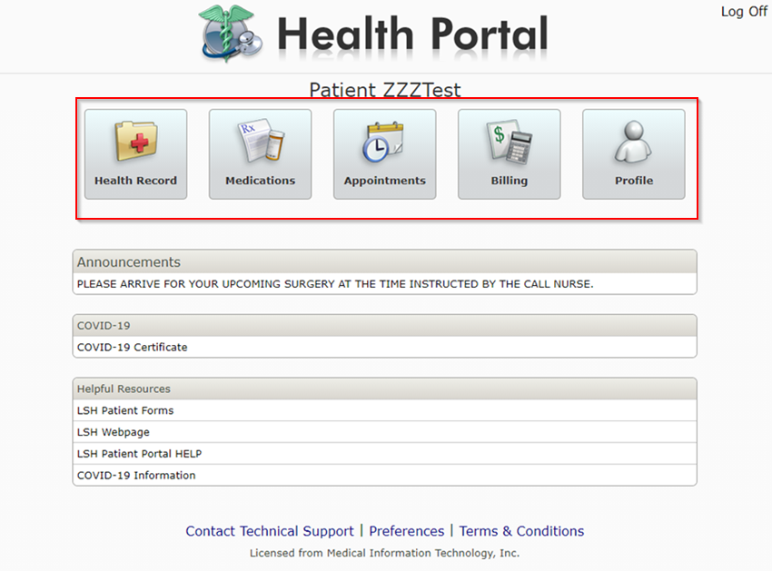

Helpful Resources
The home page has a Helpful Resources section providing hyperlinks to other pertinent webpages.
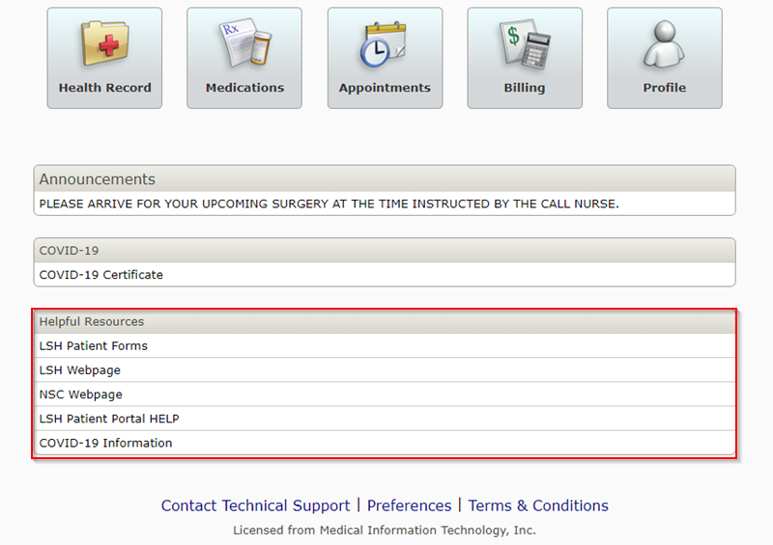

Contact Technical Support
The Contact Technical Support provides users contact information to assist with different types of inquiries.

Preferences
Preferences allow the user to set personal preferences regarding their preferred email and passwords. Preferences allow the patient to view their current proxy access, email and communication preferences, the default user upon sign in, as well as provides an outlet where the user can update their password. Users can update their preferences by selecting the Preferences footer button within the Patient Portal.
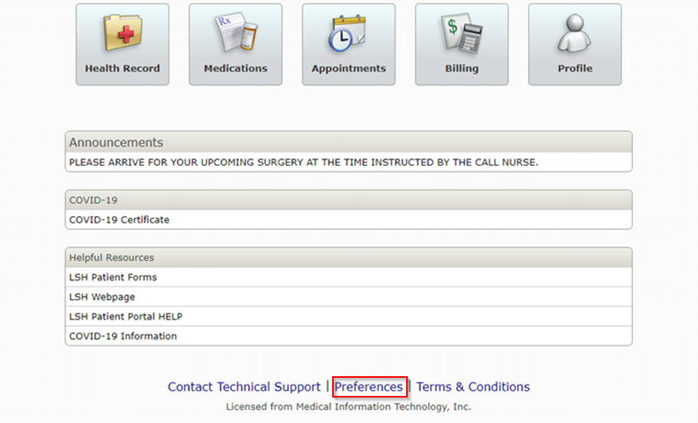

Preferences Main Page
To enter the main page of Preferences, select the Preference button on the footer region of the main page. The Preferences main page displays the preference for receiving email notifications, as well as provides a list of patients to which the user has proxy access.
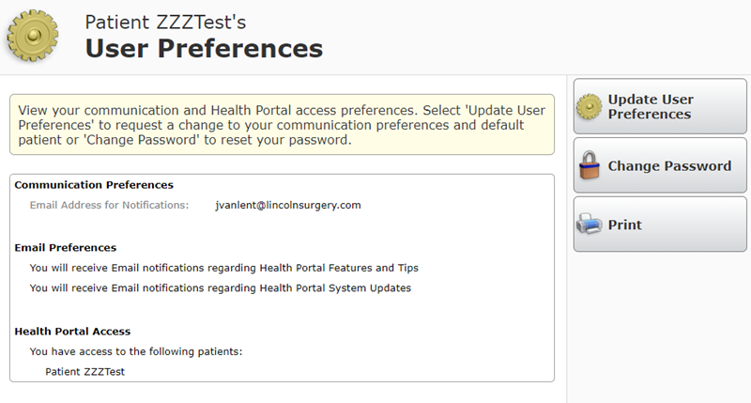

Update User Preferences
To update preferences, select the “Update User Preferences” button. The “Update User Preferences” button allows the user to update their email settings, as well as select the default patient at logon for their portal account.
To enter in a new email, the user needs to enter the new email, re-enter the new email address, and provide their portal password to confirm the change.
To select a default patient, select the arrow to view the list of patients to which the portal user has access. The selection here will determine which patient is seen when the user logs in to the portal.
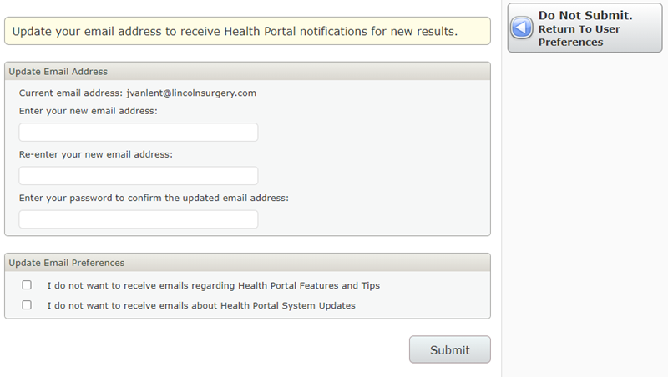

Change Password
The “Change Password” button within the Preferences main page instructs the user on how to create a new password.
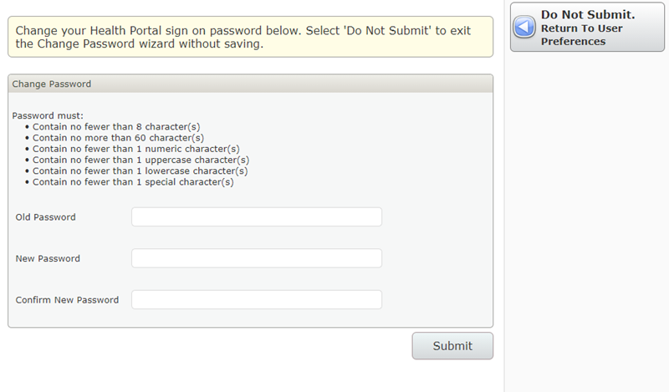
Click to return to Table of Contents

Terms & Conditions
The Terms of Use and User Agreement are accepted by the user upon first log on to the Patient Portal. The Agreement is accessible from the Home Page for Portal User review.
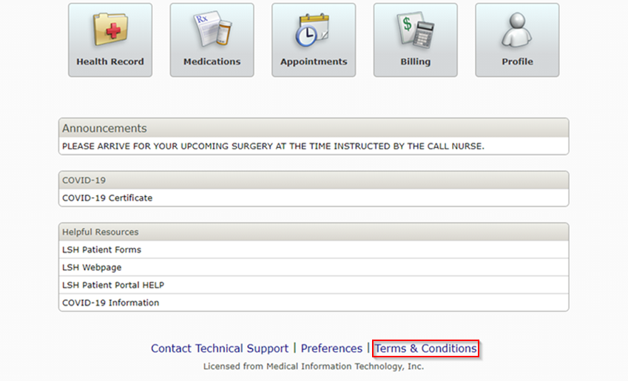
Click to return to Table of Contents

Health Record
  - The Health Record presents patients with a quick snapshot of pertinent information regarding their health. 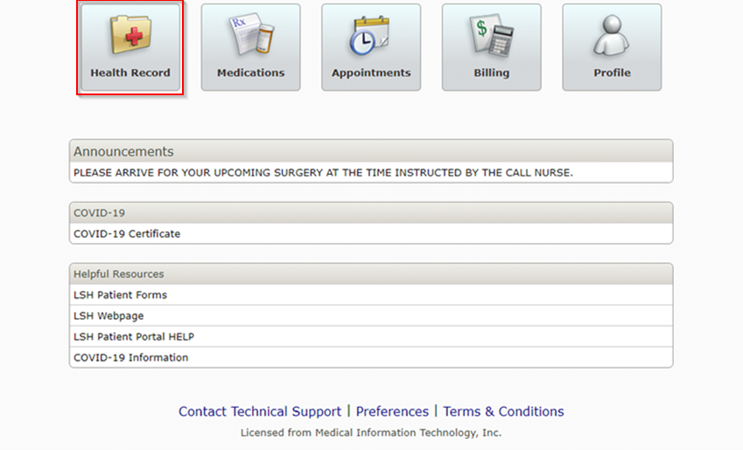
For example, users will have access to the following:
- The Health Summary section provides the user with the ability to view, download, and transmit their Health Summary.
- Visit Summary section provides a view of previous visits and allows selection for visit details, instructions, and forms.
- The Results section includes laboratory tests and microbiology procedures.
- The Medications section is identical to the Medications button available on the homepage. This feature provides patients with a view of their home medications at the time of their last visit to Lincoln Surgical Hospital or Nebraska Surgery Center.
- The Allergies and Conditions section includes the patient’s current allergies, and active medical problems from the Electronic Health Information System’s problem list.
- Reports section Includes documentation completed during your visit such as Operative Report, Clinical Notes etc..
- Documents section includes Letters, Reports, Results, Visits, Medical Profile, Billing and Other documents made available to patients for viewing, downloading and printing.
- Questionnaires section provides links for patients to complete their pre-registration process and documentation prior to their upcoming appointment.

Health Record Main Page
The main page of the Health Record provides a summary of the patient's record. The table summary provides shortcuts to the details of each item presented. The order in which the table displays is as follows:
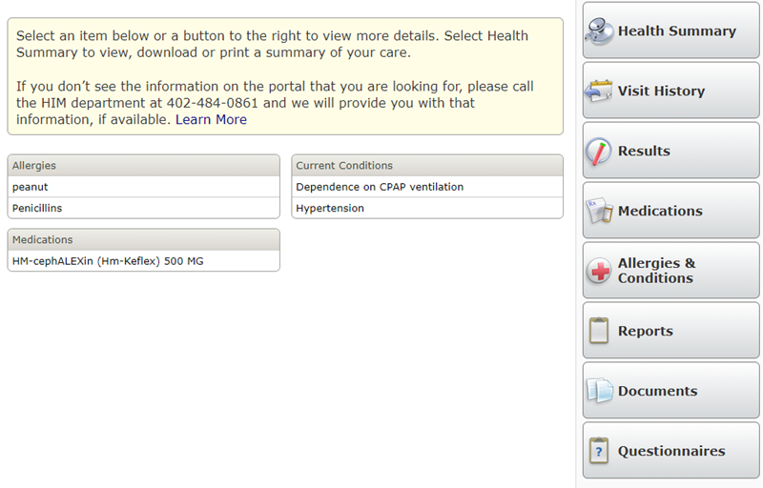
If there is no data for a particular item, it will indicate that there is no information available.
The Health Summary is a patient level summary that is accessible within the Health Record main page. The Health Summary area of the Patient Portal is where Portal users have the ability to view and download the Health Summary.
An additional document called the Inpatient Summary is a visit level Health Summary. You will be able to find more information on the visit level Health Summary within the Visit History page.
Health Summary Main Page
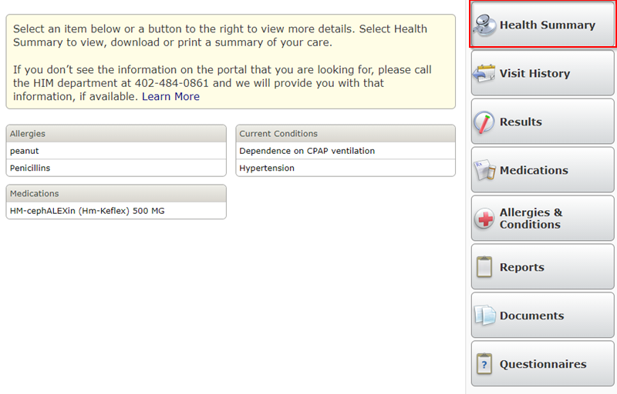
If there is no Health Summary on file for the Patient, a request will be sent to compile a new Health Summary. Once the Health Summary is created, the header will display the following:
- Patient Name
- Sex
- Date of Birth
- External Reference #
- Date of Health Summary creation
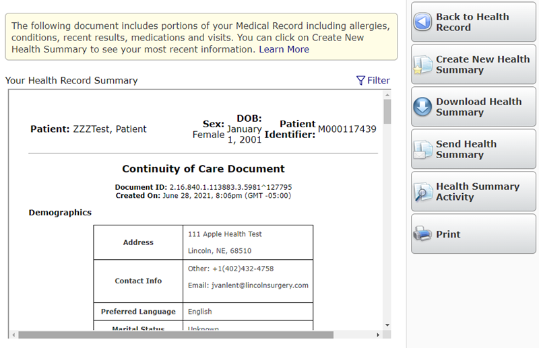

Create New Health Summary
The Portal User can only compile a new Health Summary once a day.
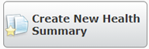

Requesting a New Health Summary
Once a Portal User clicks to create a new Health Summary, a message will display the following:
- We have submitted your request to create a new health summary. Please check back at a later time to view your health summary.
A new Health Summary will be generated for the Portal User within ten minutes. The time it takes to generate a new Health Summary is based on the amount of information that needs to be pulled into the Health Summary.

New Health Summary
Once a new Health Summary is created, the Create New Health Summary button will no longer be displayed on the Health Summary main page. The button will reappear the following day.

Download Health Summary
Portal Users will be able to download their Health Summary through the Download Health Summary button on the Health Summary main page.
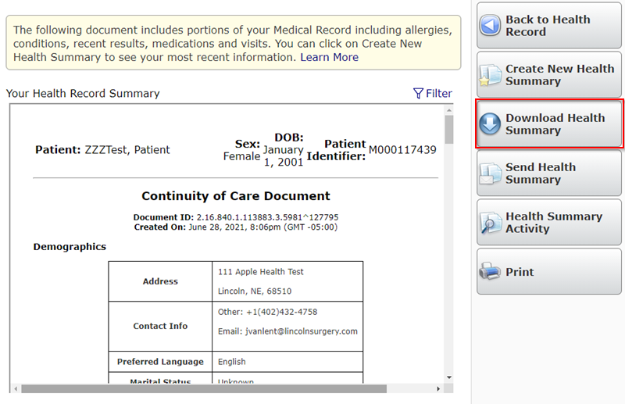

Download Health Summary Detail Page
Upon accessing the Download Health Summary page, the Portal User will be presented a list of instructions on how to download and then open the zip files. In order to generate the download of the zip files, the Portal User must enter in a password that is between 8 and 32 characters long. The Portal User will need to re-enter in the password before viewing their downloaded Health Summary.
Note: In order to extract the Health Summary, the Portal User will need to use software that supports extracting password protected zip files.
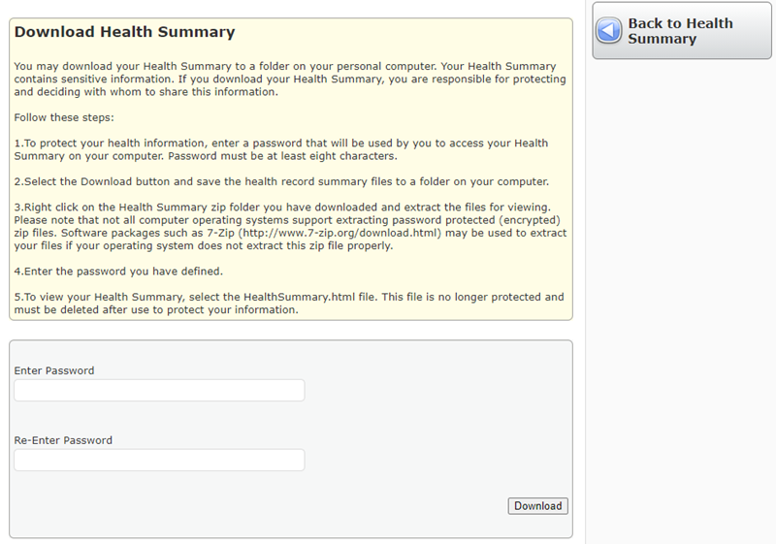

Download Health Summary Zip File
Once a Portal User enters their password and clicks download, the download process is initiated. The file name will default to "HealthSummaryMMDDYY.”
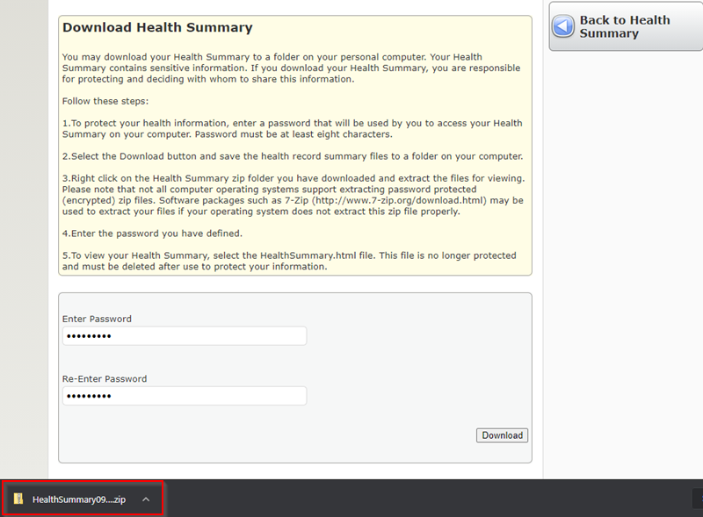

Extracted Health Summary Files
Once the files are extracted, using Advanced Encryption Standard Software the folder will contain the following:
- ccd.xsl
- HealthSummaryMMDDYY.xml
- HealthSummaryReadMe.txt
Note: The ccd.xsl will contain the raw data that allows the HealthSummaryMMDDYY.xml to be read-able.
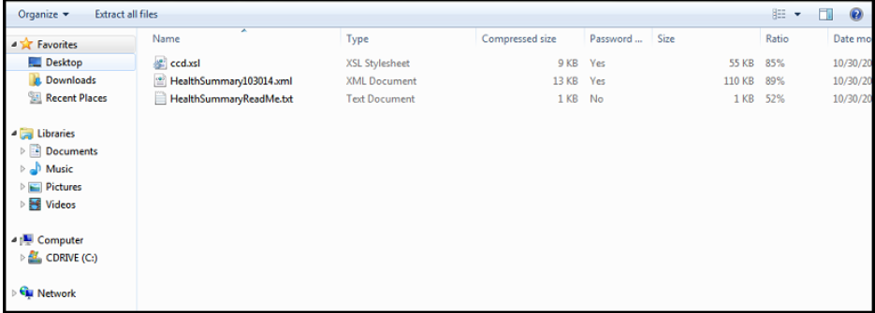

Health Summary Read Me Text
The Health Summary Read Me text is a document that gives instructions on how to view the downloaded Health Summary.
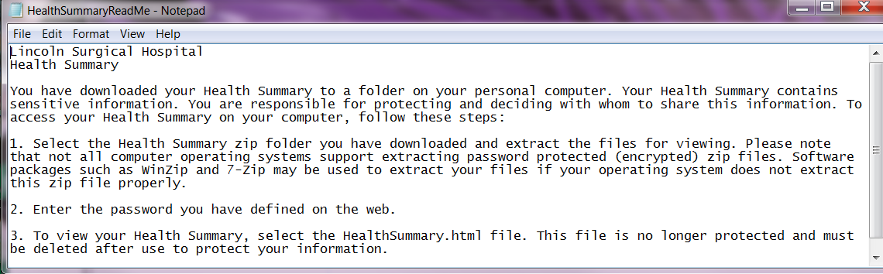

Health Summary xml File
The Health Summary xml file will open into a Portal Users default Web browser. It will contain the same information that can be found in the Patient Portal, as well as confidential Laboratory results that have been restricted from Patient Portal view.
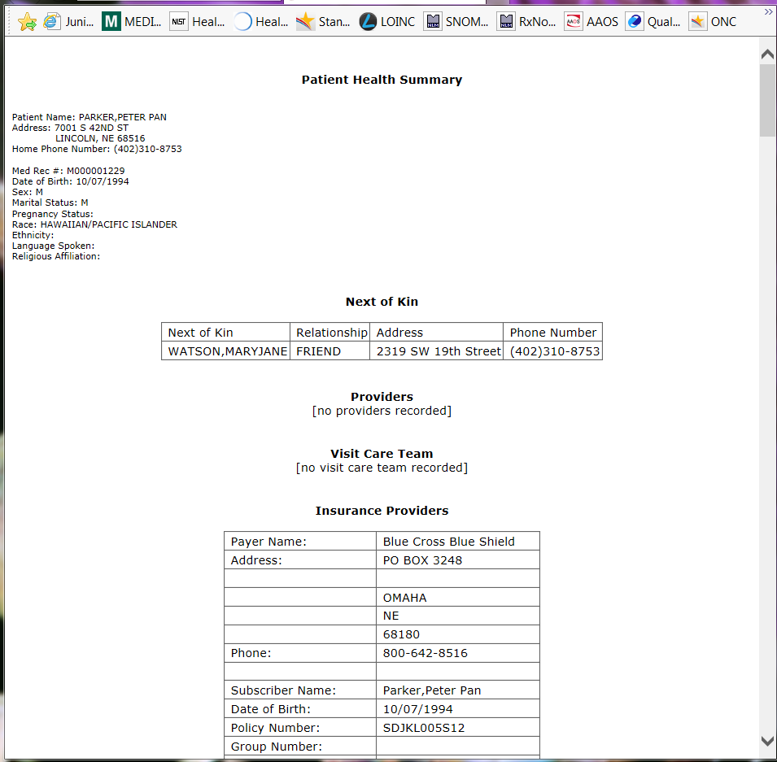

Send Health Summary
Securely exchange your Health Summary with your provider or share it through an email. Contact your provider to obtain their eHealth Exchange address.
To send your Health Summary to a provider with an eHealth address, enter your provider's eHealth Exchange address and select Send. To send your Health Summary to an email address, enter the desired email address and select Send.
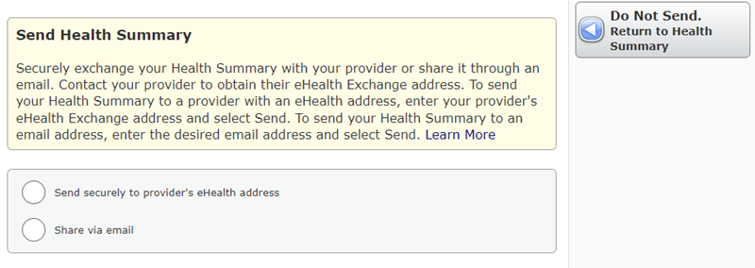

Health Summary Activity
The Health Summary Activity button is located on the main Health Summary page. The health Summary activity will give Portal Users a log of activity within the Health Summary section of the Patient Portal.
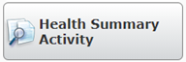

Health Summary Activity Detail page
The Health Summary Activity Detail page will display the following:
- Date and Time user accessed the Health Summary
- User
- Action (View, Download, Send)
- Description of page that was viewed

Print Health Summary
Portal Users will be able to print their Health Summary by accessing the Print button found on the Health Summary main page.
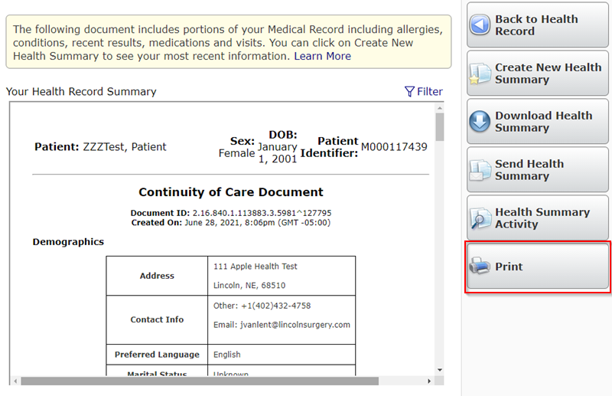

Print Health Summary Detail Page
The Print button will open to print friendly screen. The Portal User will then need to print the Health Summary through their browser.
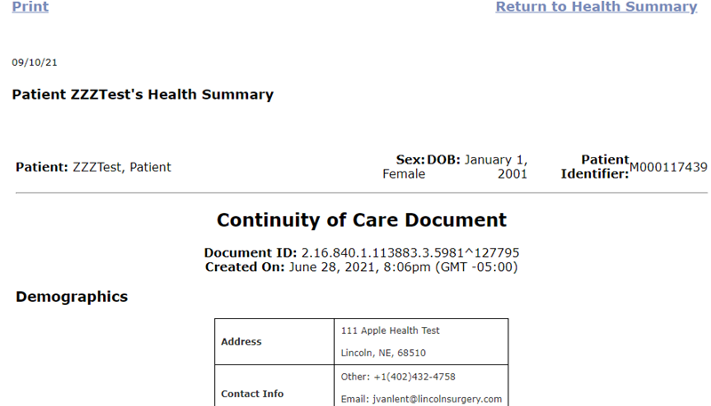

Click to return to Table of Contents

Visit History
Visit history displays the history of the patient's visits from the Lincoln Surgical Hospital or Nebraska Surgery Center. This section of the Health Record provides a way for Portal Users to review the details of all visits. These may include a summary of the visit, a report that includes clinical information regarding the visit, and follow up forms such as patient care instructions.
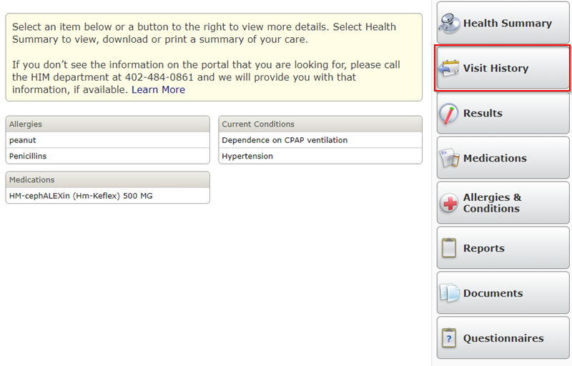

Visit History Main Page
The Visit table sorts by date in a reverse chronological sort, but the display order can be changed by selecting any of the headers (Visit Date, Type, or Visit Location). The table displays the following elements: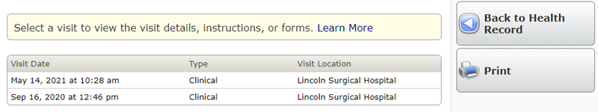
- Date
- Time
- Visit Type (Emergency, Clinical Outpatient, Inpatient, Ambulatory)
- Visit Location or Reason for Visit

Visit History Detail Pages
Selecting a visit, presents the Portal User with the following information:
- Visit Summary including Providers and Reason for Visit or Location
- Patient Visit Report
- Links to Instructions Given
- Links to Forms Given
- Care Team
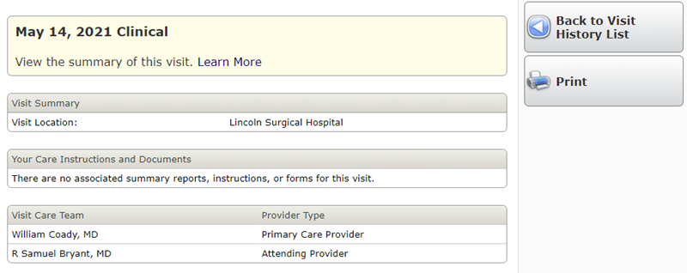
The Inpatient Visit Report includes the following:
- Visit Location
- Visit Data Health Summary
- List of Instructions
- Additional Instructions
- Referrals
- Non-Stand Alone Forms
- Visit Care Team
Providers included in the Visit Care Team can be selected, for the Portal User to retrieve additional contact information. Such as:
- Specialty
- Address
- Primary Phone
- Fax
Click to return to Table of Contents

Results
The results area of the Patient Portal is accessible within the Health Record Main Page. The Results area of the Health Record generates new activity, which will create a Red dot on the Health Record section within the Home Page.
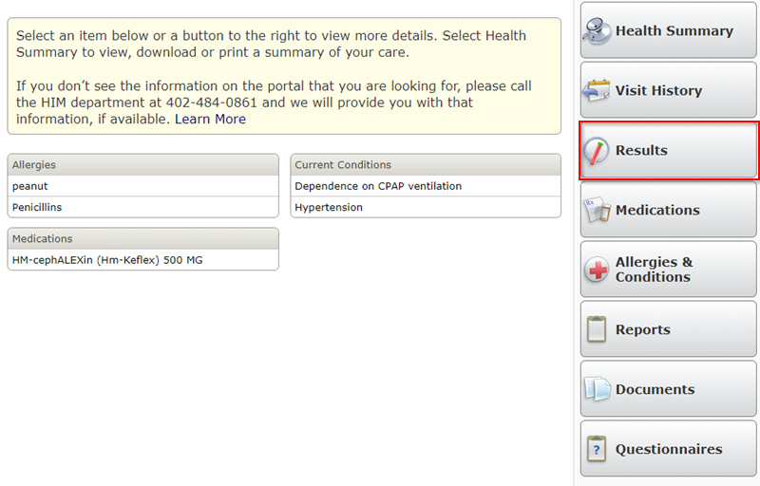

Results Main Page
The Results area of the Health Record lists out Laboratory (LAB) and Microbiology (MIC) results for the patient. The main page displays the Laboratory or Microbiology result and the result detail page will show the history of that test. The results are displayed by individual tests. The Patient Portal will display both inpatient and outpatient results. Confidential LAB and MIC results will be restricted from view on the Results tab; however, those confidential labs will be viewable from the Health Summary Report.
The Results main screen table for both Laboratory and Microbiology includes the following:
- Date of Last Result
- Test
- Result
- Reference Range
- Flag
The table is sorted in reverse chronological order with the most recent tests first.
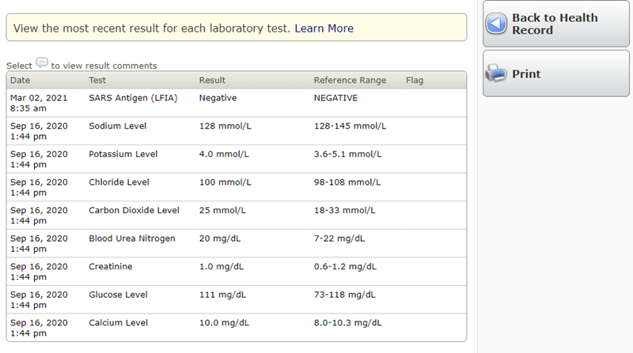

LAB Results Detail
Selecting a result brings the Portal User to the detail page of that test. When selecting a particular test, the Patient Portal displays the history of all results for that specific test. The following elements are available on the screen:
- Date
- Result
- Reference Range
- Result Flag (Low or High)
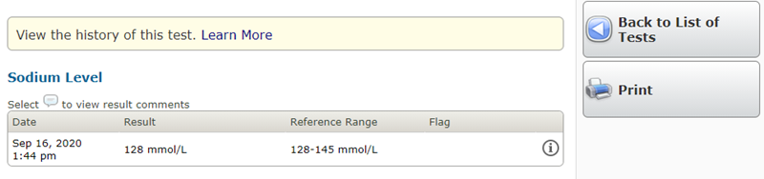

LAB Results Comments
Selecting the icon to the right of the result will bring up Laboratory Result Comments.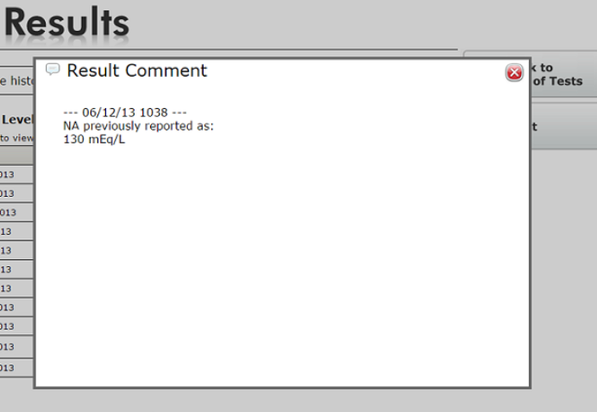

Microbiology Result Detail
Selecting the procedure navigates the Portal User to the detail page. The procedure description displays the following:
- Source
- Collected date and time
- Resulted date and time
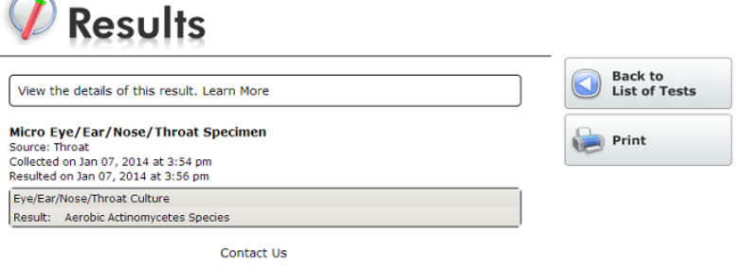
- Results

Click to return to Table of Contents

Medications
  - The Medications area of the Patient Portal provides the Portal User with a way to view their active home medications and access information about the medication they are taking. Medications may be accessed directly from the “Medications” button on the Homepage or from within the “Health Record” button.
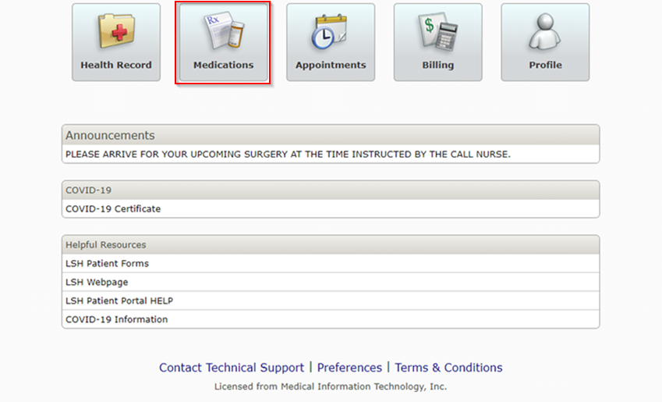

  - 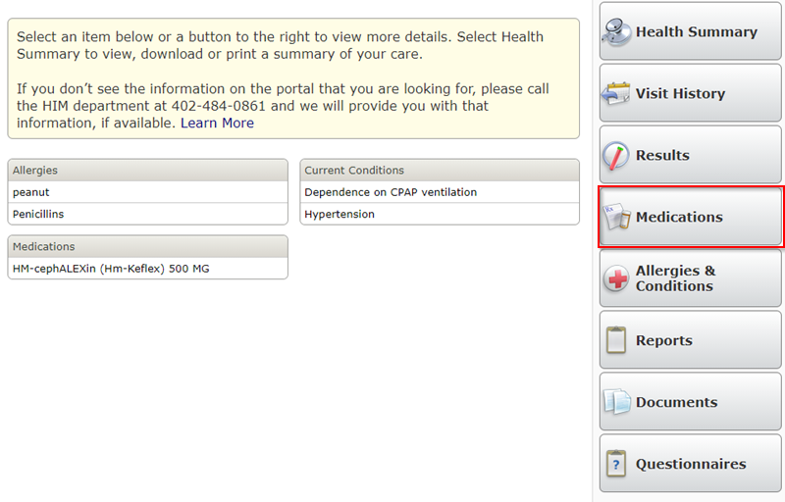

Medications Main Page
By selecting the Medications button from the homepage, the Portal User is presented with a list of the patient’s home medications since last visit to Lincoln Surgical Hospital or Nebraska Surgery Center.
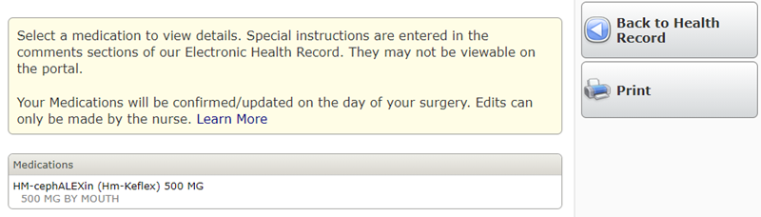

Medication Detail Page
Clicking on anywhere on the medication line brings the Portal User to the medication detail. The detail page displays the following information: Medication Generic Name (trade name), Dose, Form, Route, How often, Reason for Use, Prescribing provider, Total Refills, Last Updates, and Additional Instructions.
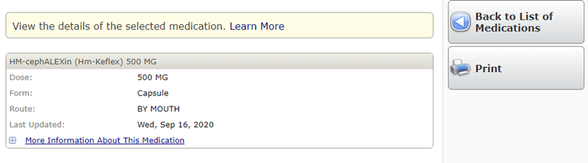
Clicking on the link "More Information About this Medication" displays the pharmacy medication handout.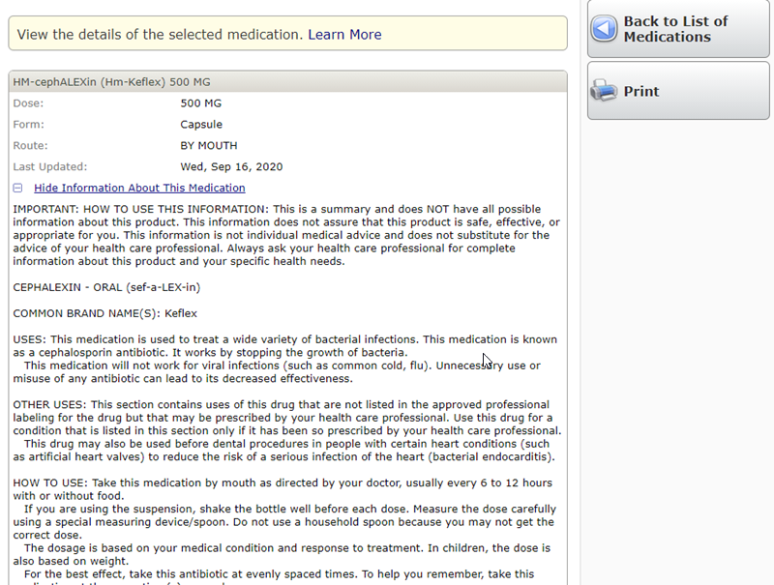Click to return to Table of Contents

Allergies and Conditions
Allergies and conditions can be seen from the Health Record main page, as well as when the Allergies & Conditions button is selected. This area of the Patient Portal allows patients to see their active Allergies, as well as their active Conditions. On the Health Record, main page the Allergies table will display as many active allergies as the patient has on record. The conditions table will display as many active problems that the patient has on the Problem List in the Electronic Health Information System.
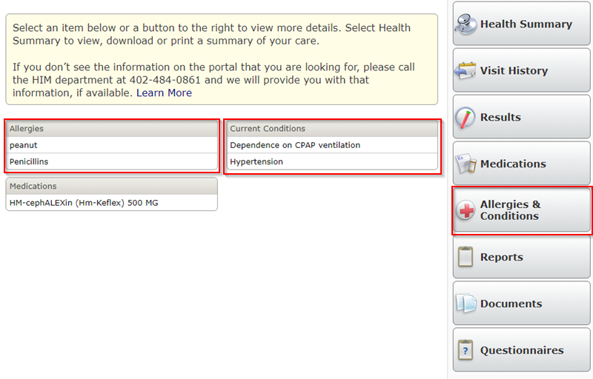

When in the Allergies and Conditions main page, allergies and conditions are listed in two separate tables. In this screen, Portal Users may select a specific allergy or condition to get more information.
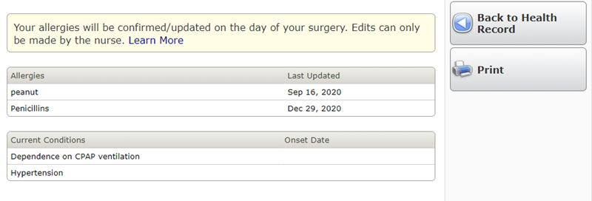

Allergy Detail Page
Clicking on an allergy brings the Portal User to the detail page of that allergy. The Allergy detail displays the following information from the display in the Electronic Health Information System:
- Type – either Allergy or Adverse Reaction
- Date Last Updated
- Reaction – the applicable entry selected from the Allergen Reaction dictionary
- Severity – Mild, Intermediate, Severe, or Unknown
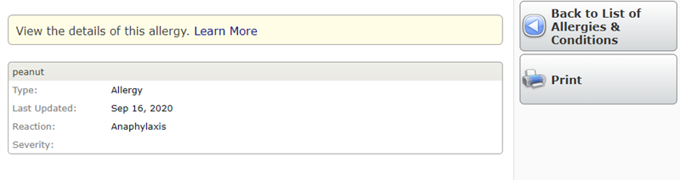

Conditions
The conditions table displays the active problems from the problem list as defined in the Electronic Health Information System. Inactive problems are not included in this list.
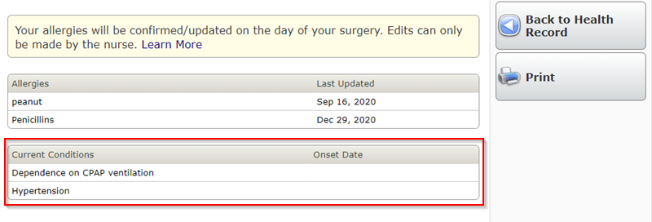
Click to return to Table of Contents

Reports
Includes documentation completed during your visit such as Operative Report, Clinical Notes etc..
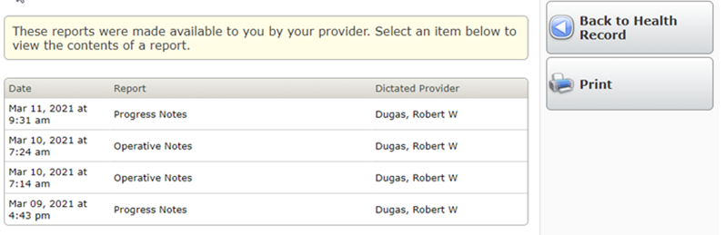

Documents
Includes Letters, Reports, Results, Visits, Medical Profile, Billing and Other documents scanned into a patients chart and made available to patients for viewing, downloading and printing.

Questionnaires
Questionnaires section provides links for patients to complete their pre-registration process and documentation prior to their upcoming appointment.
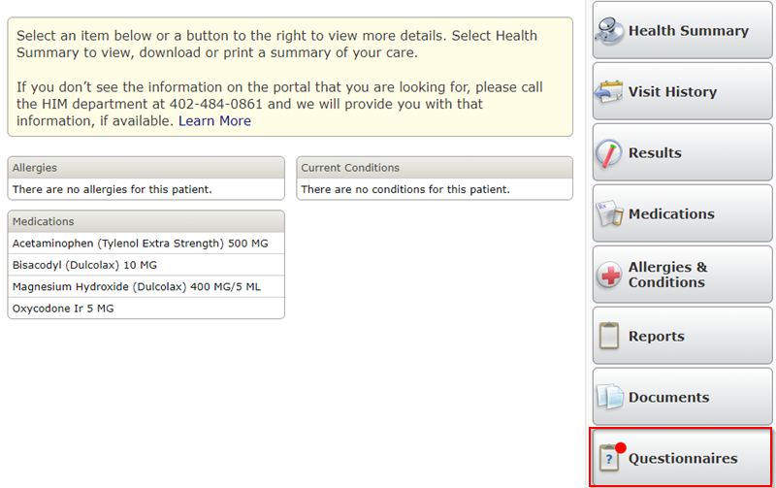

Questionnaires Main Page
Summary table with each questionnaire that will need to be completed prior to upcoming appointment is within the Questionnaires section.
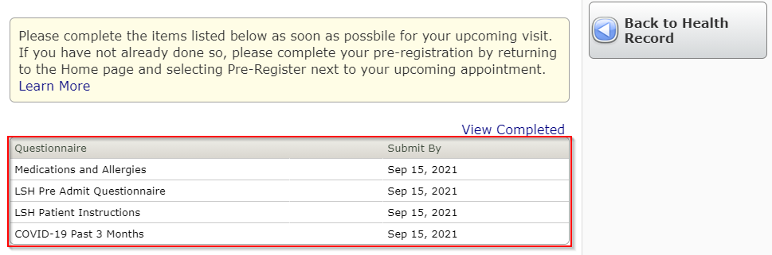

Questionnaires Detail Page
Click each questionnaire to open the detail and complete all questions. Once complete select Submit.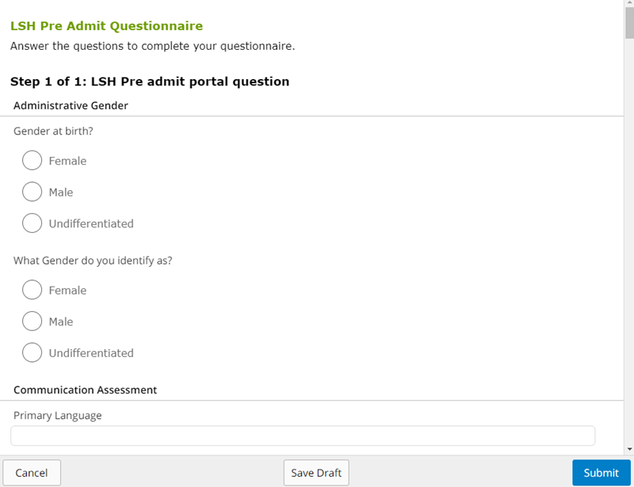

Appointments
Provides a list of upcoming or pending appointments to Lincoln Surgical Hospital or Nebraska Surgery Center.
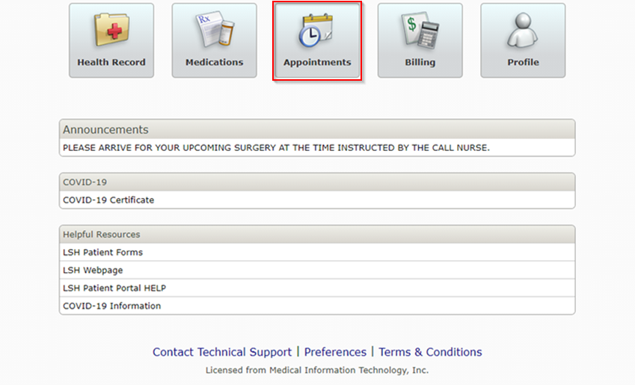

Billing
The Patient Portal includes an option to view Billing and Accounts Receivable accounts. 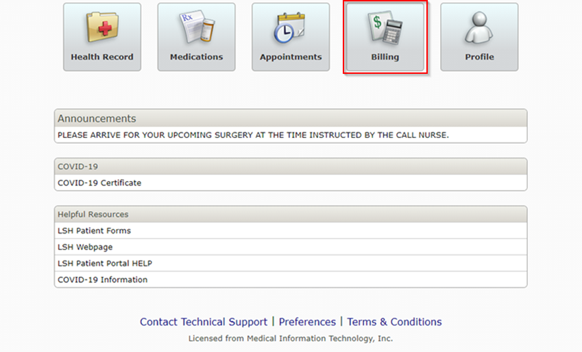

Billing Detail
Selecting an account on the main billing page brings the Portal User to a detail page that lists transactions for the account.
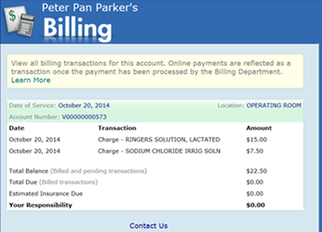
Click to return to Table of Contents

Profile
The Profile area of the Patient Portal provides a way for a Portal User to communicate information about the patient including Demographic Information and Contacts.
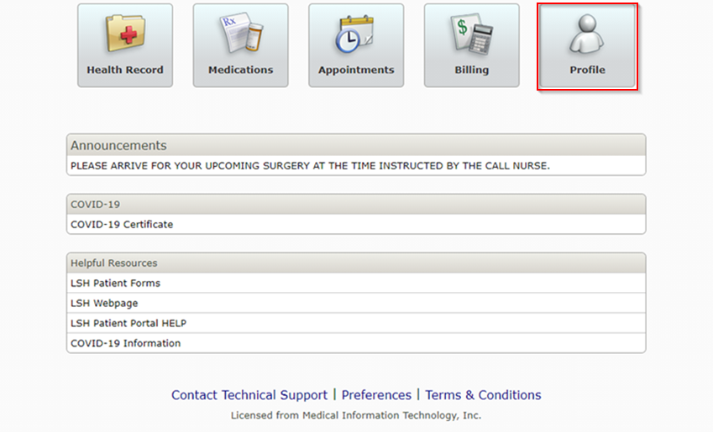
All information changed in the Portal is sent to the Health Information Team for review. The Hospital Staff may update the information and this change is then reflected in the Patient Profile display below.
The Profile page has three categories of data: Demographic Information, Contacts, and Shared Access.
The Shared Access displays the Portal Users that have access to the selected patient’s information.
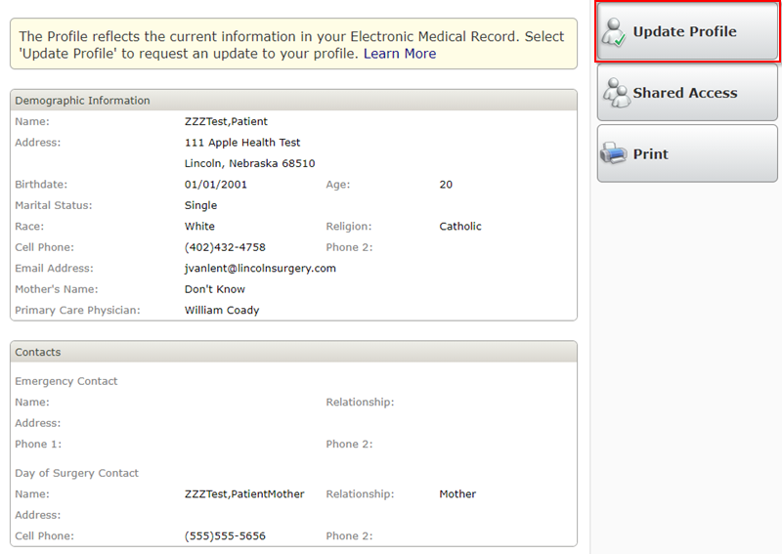

Update Profile Wizard
Clicking on the “Update Profile” button in the right hand column will launch the user into the Profile Wizard. This is used to update a patient’s profile information, which includes person and contact information.

Page 1: Demographic Information
Patient information defaults into the following fields from the Lincoln Surgical Hospital and Nebraska Surgery Center Information System (if the data is available):
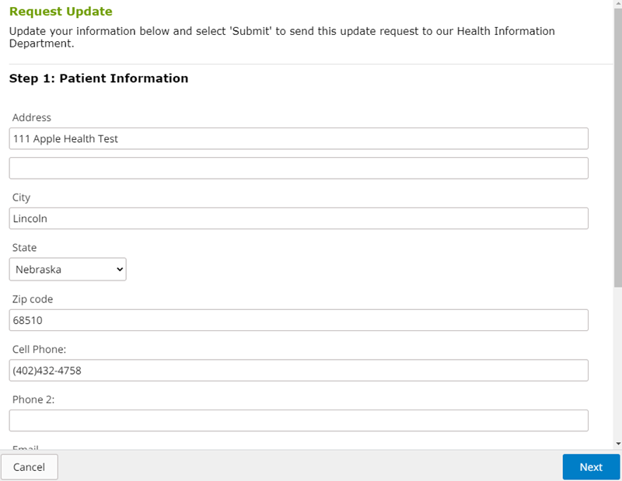

Page 2: Contact Information
Contact information will default in according to what is stored in the Electronic Health Information System:
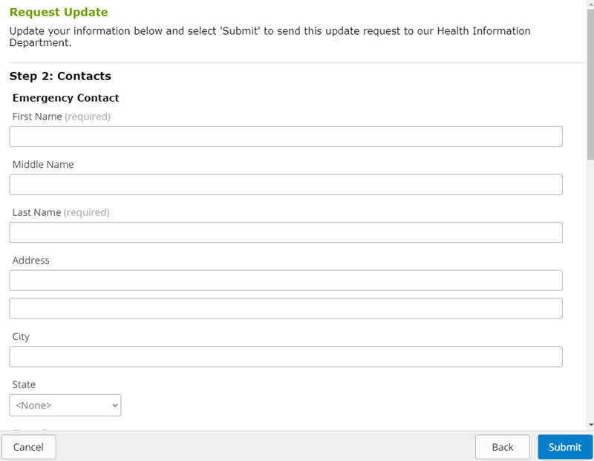
As with the Demographic Information tab, a Portal User can update all of the available fields if he or she desires.

Confirmation Screen
Once the request to update information has been submitted, a confirmation screen will appear.

Shared Access
To allow others to access your Patient Portal information.
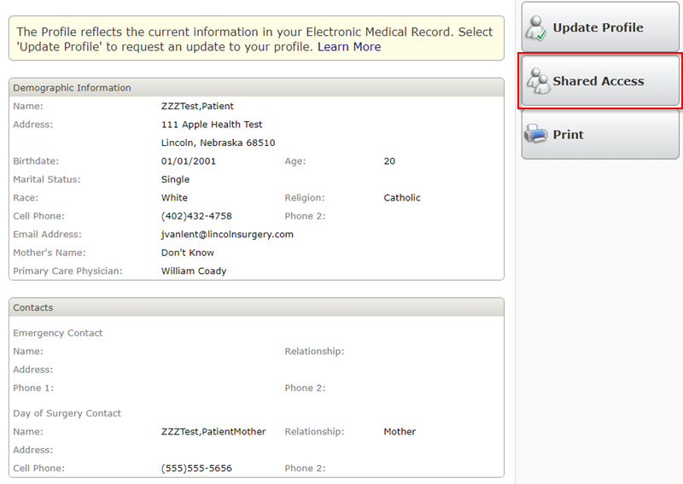
Select Create Invitation button.
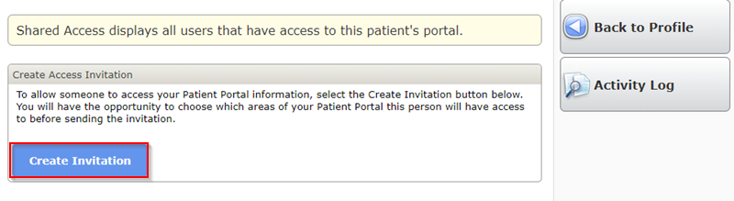

You will have the opportunity to choose which areas of your Patient Portal this person will have access to before sending the invitation.
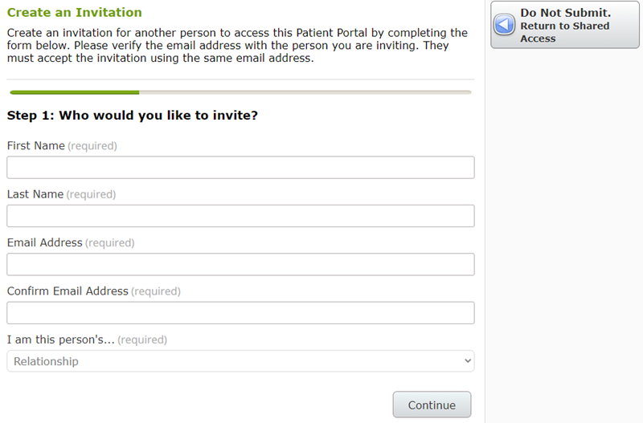
Return to Table of Contents

